Creating Sequence Diagrams

Creating the Dynamic Model View 1
Extending the Sequence Diagram 15
Composition and Aggregation Revisited 19
Composition 19
Aggregation 20
Spotting Errors in Return Values 23

Creating the Dynamic Model View

If you haven’t done so already create the dynamic model view in Enterprise Architect by right clicking on the model and adding a new view…

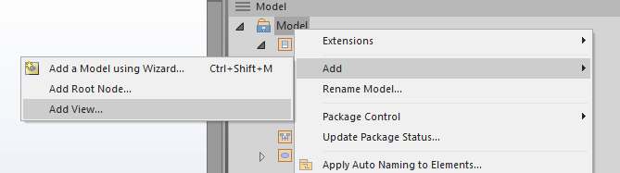
Set the view up like so…
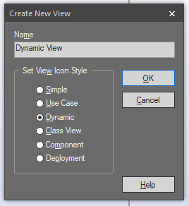
Add to the new view a package to store the diagrams in…
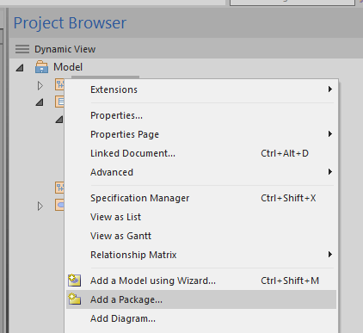
Set up the package like so…
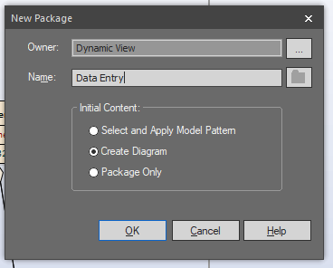
Under UML Behavioural select the sequence diagram option…
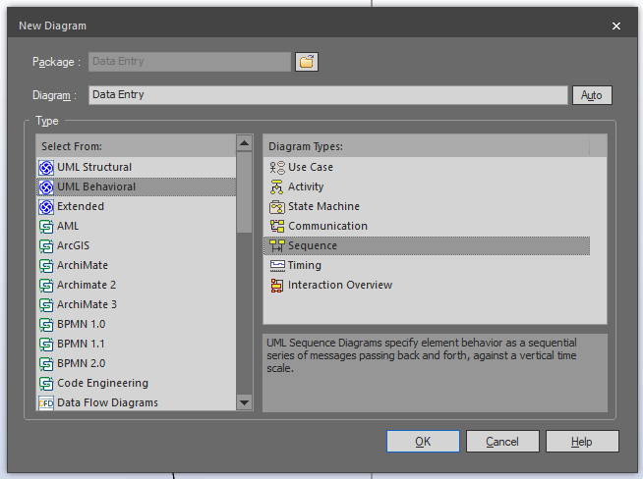
This will create the sequence diagram in the project browser…
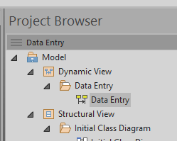
Double click the diagram to edit it.
The first thing we will add to the diagram is the actor Consultant taken from the use case diagram…
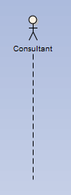
This is the actor in this case that will trigger the sequence of events.
We now need to think about what is the first action the actor will perform.
They will pick up a business card and enter the name of the company. This will cause the system to produce a filtered list of companies with their employees.
The next time line we need to add represents the class clsCompanyCollection. Do this by adding a new life line…

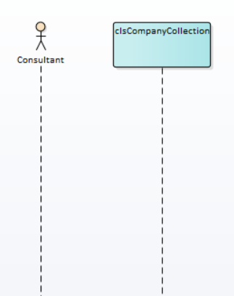
We now need to send a message to the class from the actor.
Messages may be identified by looking at the use cases on the use case diagram.
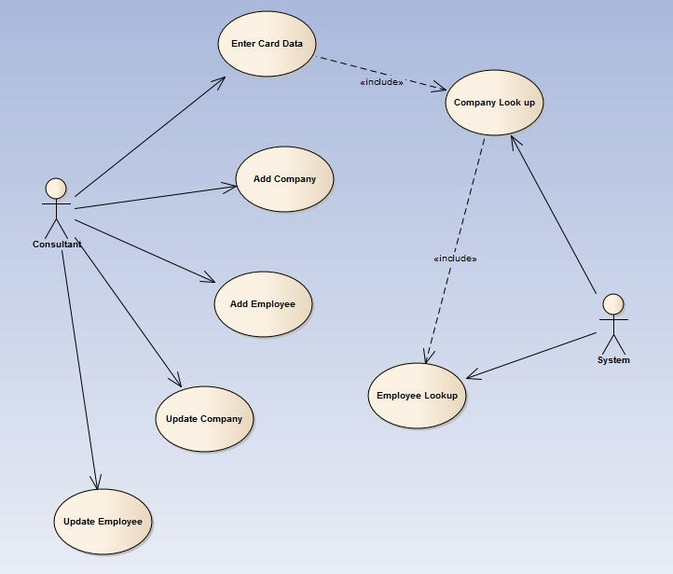
In this case “Company Look Up”
Select the message tool from the toolbox…
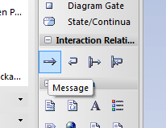
And draw between the actor and the object.
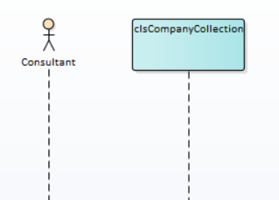
This will create the new message…
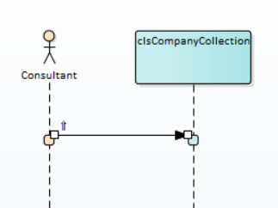
Double click the message to give it a name…
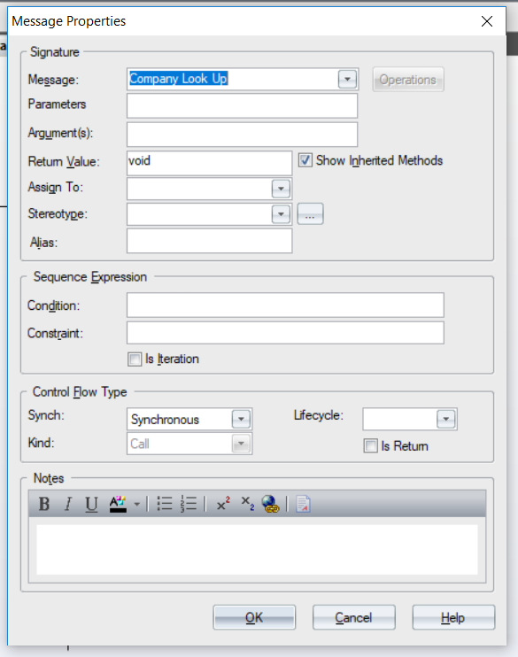

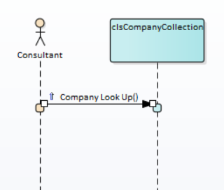
Step one complete – so what?
What we are doing here by linking the use case with the class diagram is creating a cross check on our assumptions.
As we create messages in the sequence diagram we need to make sure that it maps onto both the use case and the class diagram.
- Do we have an actor on the use case that matches the sequence diagram? Yes!

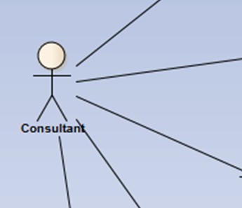
- Do we have a class on the class diagram? Yes!

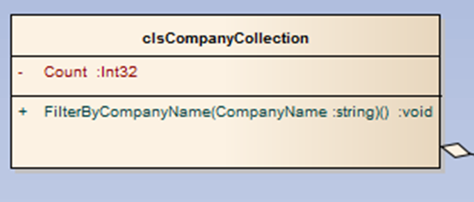
- Do we have a method in the class that is able to handle the message? Yes!

So far so good!
The next step in the use case is for the system to produce a list of employees for this company.
The sequence diagram might look something like this…
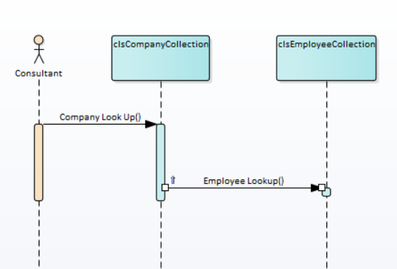
Let’s ask the same questions again!
- Do we have an actor on the use case that matches the sequence diagram? Yes!
- Do we have a class called clsEmployeeCollection? Yes!
- Do we have an operation in the class that is able to handle the message?

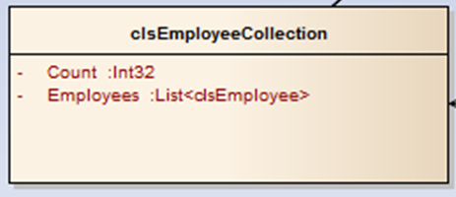
- No!

What we have done with the sequence diagram is identify a missing operation in our class clsEmployeeCollection to support the use case / message Employee Lookup.
We need some way of sending the class a company number and the class will produce a list of employees for that company.
Let’s modify the class like so…

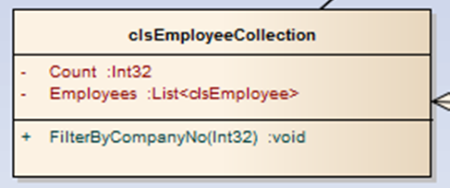

We are now able to answer the three questions positively.
- Do we have an actor on the use case that matches the sequence diagram? Yes!
- Do we have a class on the class diagram? Yes!
- Do we have a method in the class that is able to handle the message? Yes!

Now that the sequence appears complete we need to add on the data being returned from the objects.
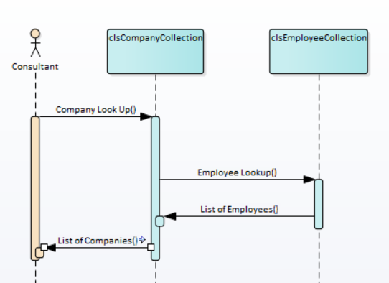
Now we have modified the sequence diagram to include data returning from the classes we need to ask the question is this functionality supported by the class diagram.
In the case of clsEmployeeCollection we have an attribute that is modified by the Employee Lookup message called Employees...

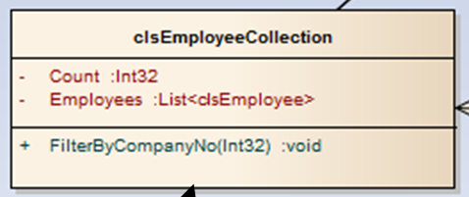
This allows us to access the list of filtered employees.
Do we have the same feature for clsCompanyCollection?
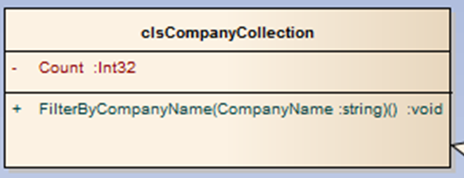

No!
So this might be added to the list of attributes like so...
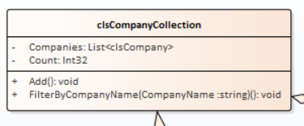
We also have lots of other useful clues to check if our analysis is heading down the right track.
From the sequence diagram we are getting clues as to what attributes need to be present in the system. Company Name and Company No being two such examples.
The other thing to consider is objects may only communicate with each other on the sequence diagram if there is a corresponding association on the class diagram.
The objects Companies and Employees must have an association between their corresponding classes.
It seems in this case that the two classes have an association missing.
Fix it like so...
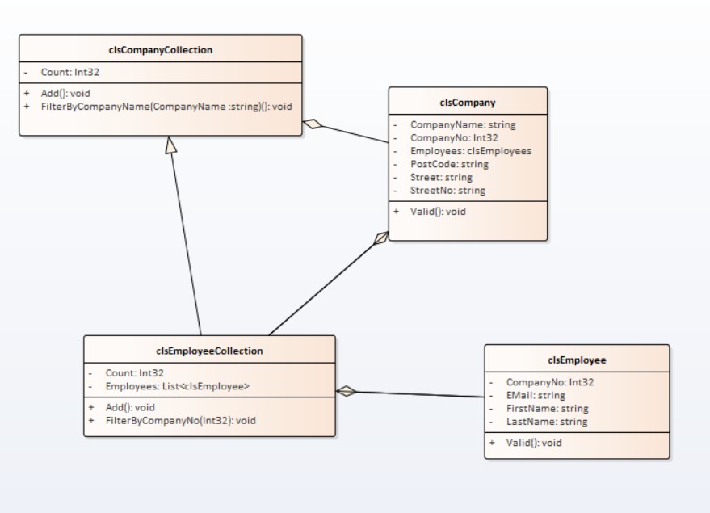

Extending the Sequence Diagram
Once we have entered the company name and established that it doesn’t exist on the system we are in a position to add a new company / employee.
Let’s add the Add Company use case / message to the diagram…
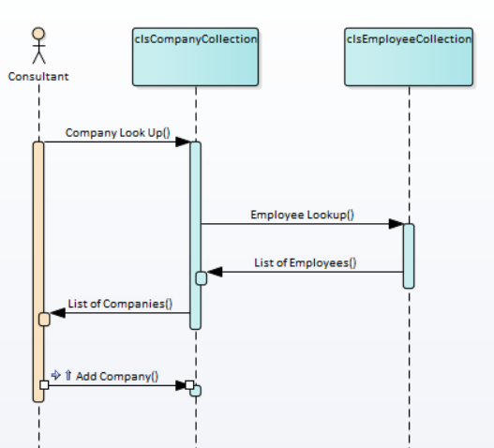
Do we have an operation in clsCompanyCollection to support this message?
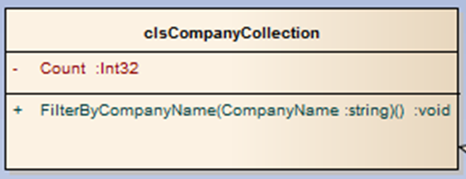
No!
So let’s modify the class diagram accordingly…
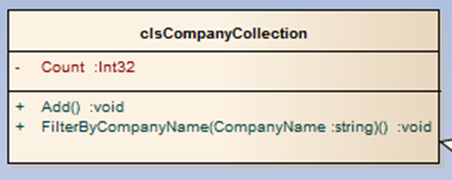
Now we need to include the Add Employee use case / message…
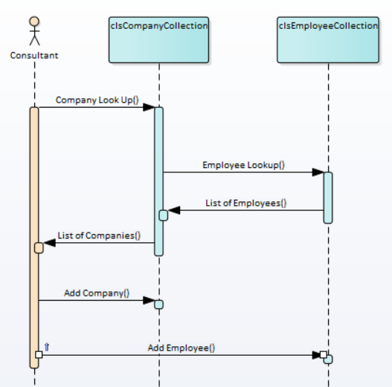
Where we find the same flaw in the class diagram as before that is no Add method…
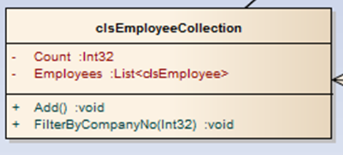
Note that we are adding the Add functionality to the collection classes.
We now hit another problem.
Is it a good idea to be adding data without any suitable validation?
One clue as to the benefits of a sequence diagram is its name – it helps us also to think about the sequence of messages / use cases in the system.
In creating the sequence diagram we have now spotted problems with both the use case and the class diagram.
We need to add some sort of validation to the use case diagram and we need to decide where to place the validation in the sequence of messages.
We will modify the use case as follows…
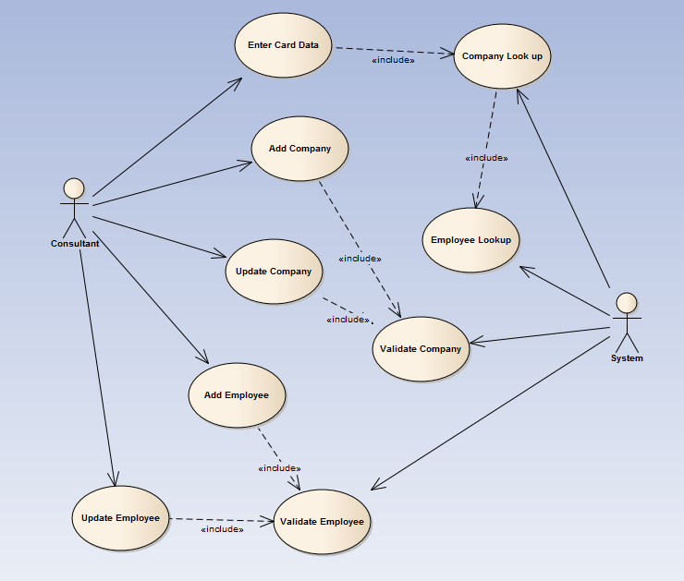
We need to decide where the validation needs to go.

Composition and Aggregation Revisited

Composition
Two classes are related via composition when you cannot have an instance of one class without the parent class.
For example if we were placing an order in a system could we ever have an order line without an associated order?
Order
Order Line
Has
1
0..*
Attributes
Operations
Attributes
Operations
The answer is “no”.
To indicate this strong relationship between the two classes we use a solid diamond like so…
Order
Order Line
Has
1
0..*
Attributes
Operations
Attributes
Operations

Aggregation
In this case we are asking the question “can this class exist without the associated class even though they have a relationship?”
A good example of this is customer and address…
Customer
Address
Uses
1
1..*
Attributes
Operations
Attributes
Operations

If all of the customers were to vanish from our store would addresses cease to exist?
Obviously the answer is they would not!
To indicate this looser relationship a white triangle is used like so…
Customer
Address
Uses
1
1..*
Attributes
Operations
Attributes
Operations

Composition and Aggregation give us important clues as to which class gets ownership of which attributes / operations.
We could design the classes like so…
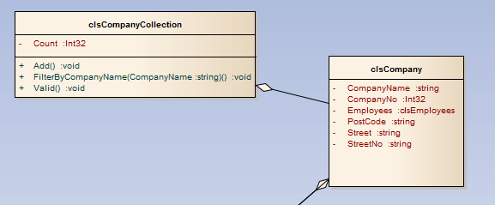
We need to ask, are we dealing with an aggregation or a composition?
Can we have an instance of a company on its own without the collection class?
The answer is “yes” we may at times need to deal with a single company on its own.
But the diagram indicates an aggregation…
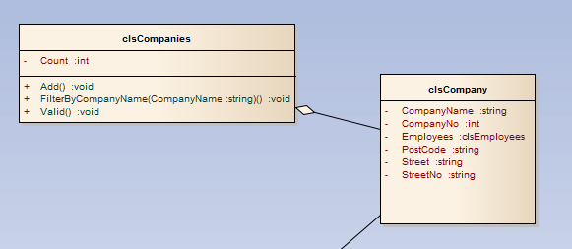
clsCompanyCollection uses clsCompany.
OK – so what happens if we want to deal with one company and we don’t need an instance of clsCompanyCollection, how do we validate the company details?
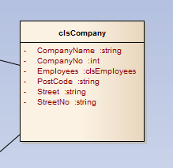
The answer is that we can’t – we have placed the validation inside the wrong class!
The diagram needs to be modified like so…
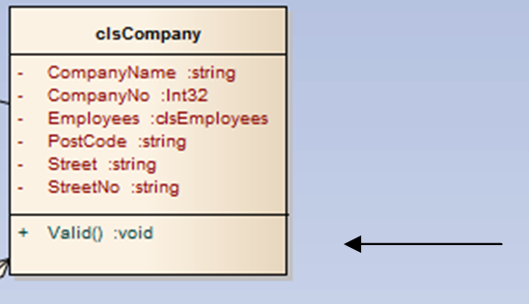
The sequence diagram starts to look something like this…
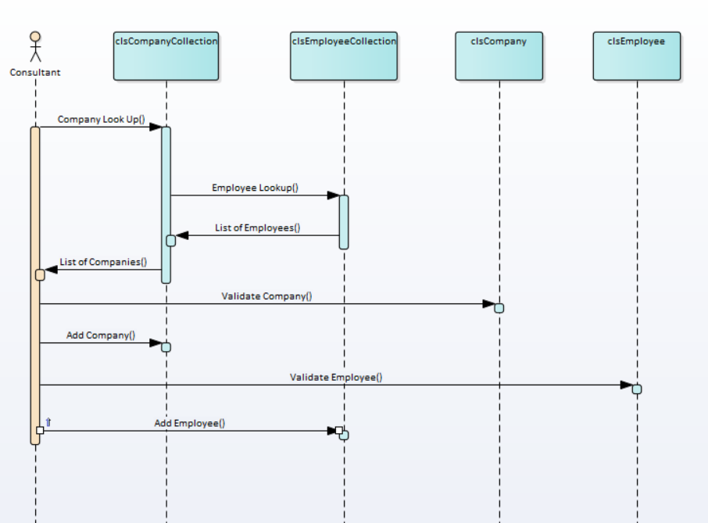

Spotting Errors in Return Values
As your sequence diagram develops it will also help you identify issues with your system when it comes to return values of operations.
Take a look at the following class...
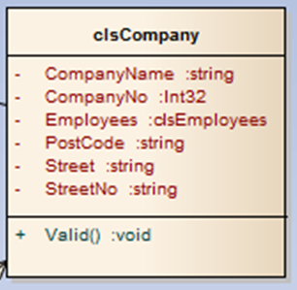
With the valid operation does it make sense that the return value if set as void?
Think about it this way.
I send the operation some data to check, what data should it come back with?
Surely some sort of error message? Does this make more sense?
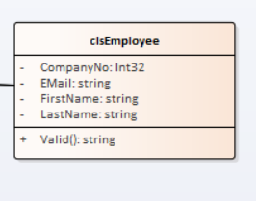
Also if the operation is returning an error message then we need to reflect this in the sequence diagram, perhaps like so...
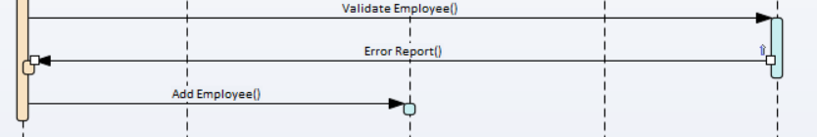
Lastly with each operation we need to think about what data needs to be sent in the message for it to do its job.
In the case of validation we need to send it some data to validate.
The operation shouldn’t then look like this...
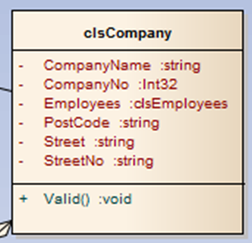
With no parameter for Valid, it needs to accept some incoming data like so...
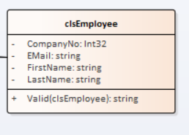
It is still important to appreciate that there is a lot of work still to do. This is a voyage of discovery and we are still a long way from producing a final map of the problem domain.
It is also important to appreciate the role the sequence diagram plays in helping us to cross check and refine your understanding of how the system is going to work.

